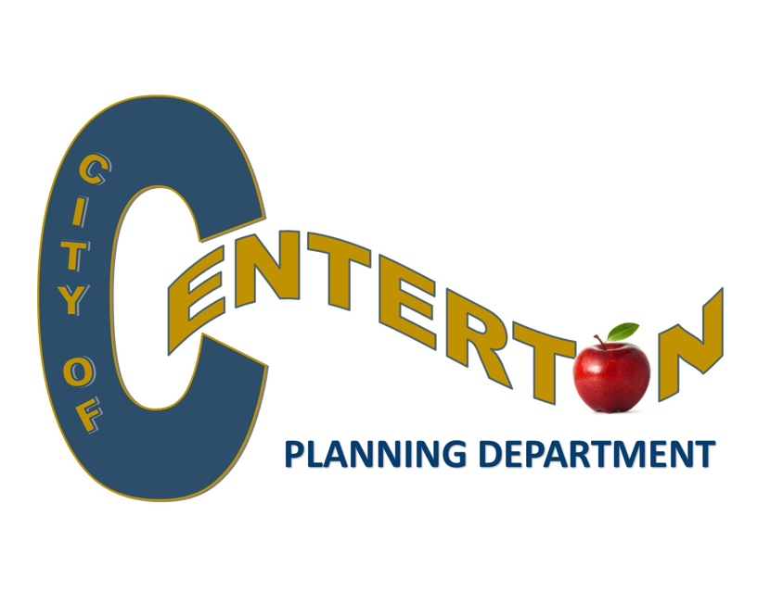
Career Opportunity
The Planning Department has an immediate opening for an
Experienced City Planner

Seeking qualified person with municipal planning experience
in review of zoning applications & new development submittals.
Must be proficient in Microsoft Office, general clerical,organizational skills,
& oral/written communications.

Application at www.centertonar.us.
Great benefits include Health insurance & APERS retirement plan.

OPEN UNTIL POSITION FILLED

SUBMIT RESUMES and SALARY REQUIREMENTS TO careers@centertonar.us

City of Centerton is an equal opportunity employer

