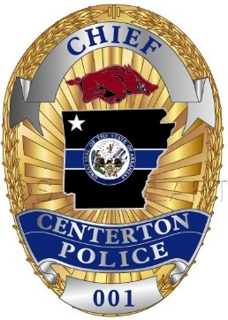
JOB OPENING

The Centerton Police Department
is accepting applications for:
FULL-TIME POLICE OFFICER
&
PART-TIME POLICE OFFICER
CERTIFIED OFFICERS PREFERRED
Applications are available online:
http://www.centertonar.us/centerton-police-department/
or in person at the Police Department, and City Hall.
Applications can be turned into
The Centerton Police Department, City Hall or emailed to careers@centertonar.us
APPLICATION DEADLINE:
Friday MARCH 19th @ 5:00pm

