NOTICE OF PUBLIC HEARING
Centerton City Council
July 5, 2022, at 6:00 PM

NOTICE IS HEREBY GIVEN that a public hearing will be held before the City of Centerton Planning Commission on July 05, 2022, at 6:00 PM at the Centerton Court Building, 210 Municipal Dr, to hear public comment and consider an application submitted by property owner Centerton Village, LLC (MOV22-01) to move a 2000 model 16’ X 46’ Clayton Mobile home into space #2 in Fair Street Village.
Property is described as space #2, 280 Fair St, Fair Street Village, City of Centerton, Benton County, AR, aka (PID 06-00133-000).
For questions or comments, contact Centerton Planning Department, PO Box 208, Centerton, AR 72719, or email planning@centertonar.us, (479) 795-2750 Ext.302. Additional information can be found at centerton.us/planning-and-zoning.
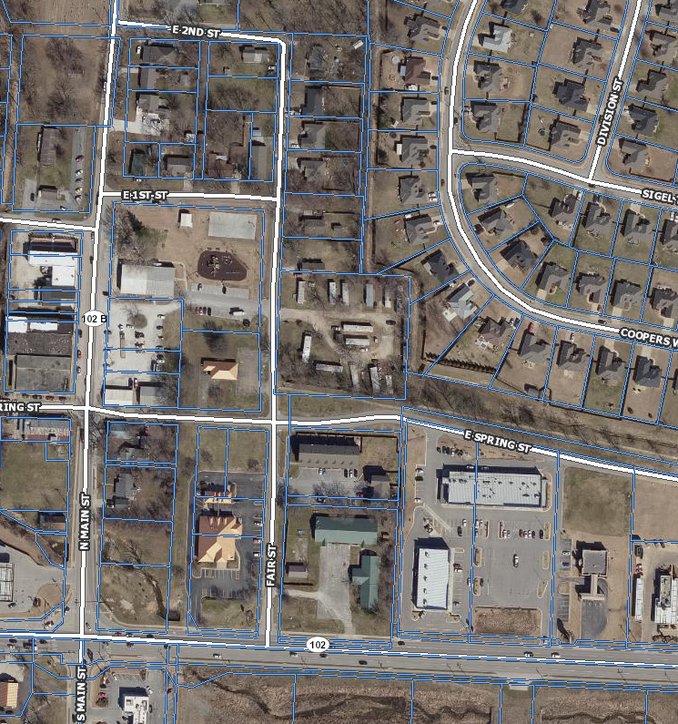
Space #2
Subject Property
Documents will be available prior to meetings for public review at www.centertonar.us/planning-and-zoning. Please email planning@centertonar.us to submit comments for consideration at the public hearing. Note that comments submitted the day of the public hearing may not be added to packets due to time constraints.

